**DevOps- Task 1**

**DevOps:**

It is the combination of cultural **philosophies, practices, and tools** that **increases an organization's ability to deliver applications** **and services at high velocity**.

**Docker:**

Docker is a tool designed to make it easier to **create, deploy, and run applications by using containers**. Containers allow a developer to package up an application with all the parts it needs, such as libraries and other dependencies, and deploy it as one package.

**Installing Docker:**

curl -fsSL https://get.docker.com | sh;

The above Command is download script to install docker. Script contains the command to install latest version of Docker.

**Docker Version:**

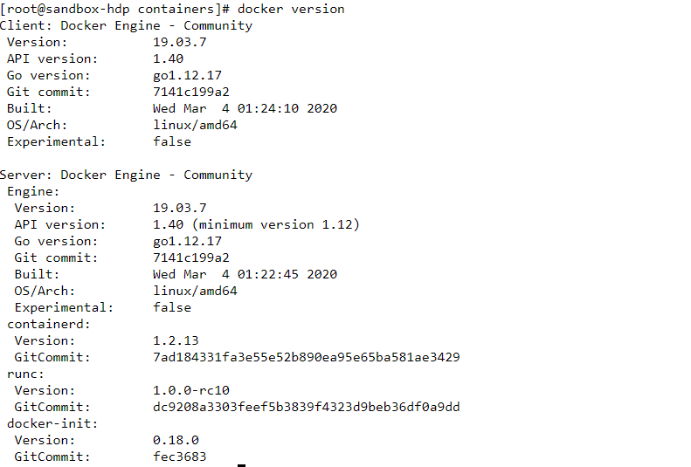

In the above image, we can see the docker version.

**Starting Docker:**



In the above image, I have started docker.

**Installing Docker:**

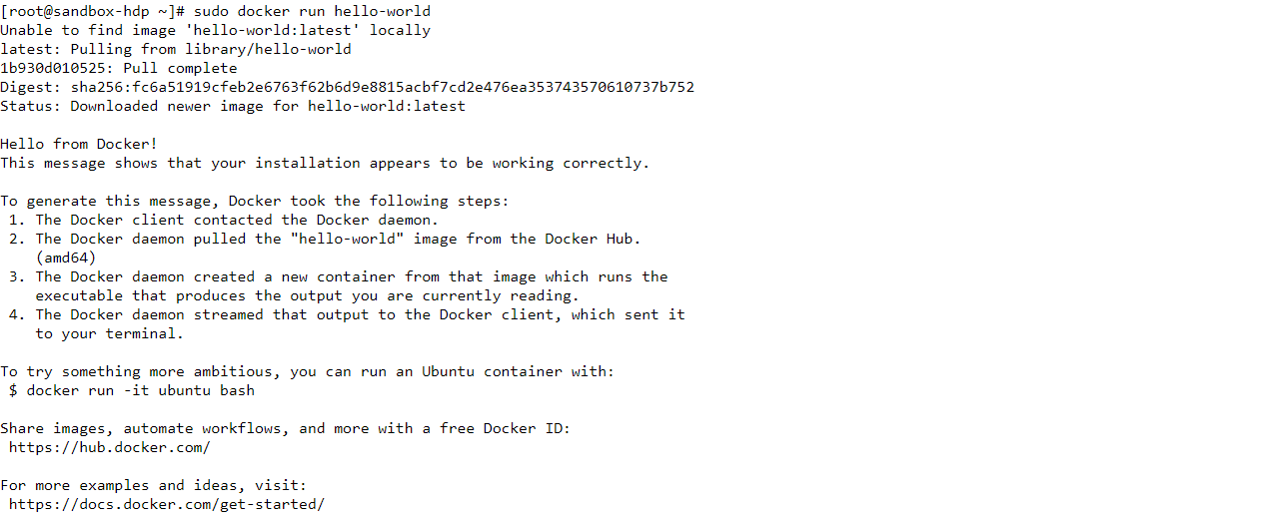

To Check Whether that docker is successfully installed or not. I have executed above command. Then, this command print “Hello from Docker! This message shows that your installation appears to be working correctly”.

**Download & Run Ubuntu latest image:**

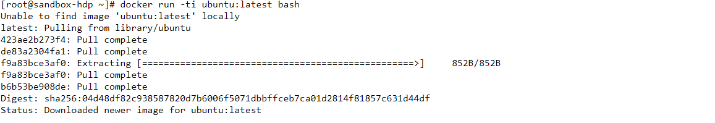

In the above image, I have installed the ubuntu image.

**Image Version:**

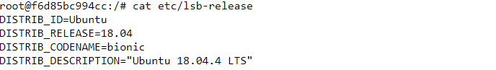

In the above image, we can see the ubuntu version.

**See current Running Images:**



In the image, we can see the currently running containers.

**Listing image files:**



In the above image, we can see the files inside ubuntu default directory.

**Create file in Docker:**



In the above image, I have created new file by name “FILE_NAME”.

**Docker exit to an Image**



In the above image, I have exited to the docker image.

**Listing Again image files:**



In the above image, there is no FILE_NAME file. Whenever we start original it starts as the fresh image. If we want to save our information in an image, we must commit our operation.

**Solution of this Problem**

**See last running Image:**



In the above image, we can see the last stopped image.

**Commit Docker Image:**



In the above image, I have committed the changes in above image.

**Docker Images:**

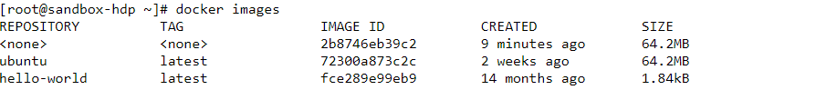

In the above image, we can see the committed image is remain unnamed. Creating an unnamed image is not a good approach.

**Give name to Docker Image:**



In the above image, I have given the image name.

**Docker Images:**



Now, we can see the docker images.

**Docker file is present in Committed image:**



Finally, our commits have been saved.

**Directly Commit Image by Name:**

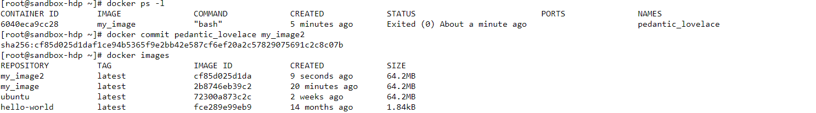

This is the simpler way to commit an image with a new name.

**Docker Log:**

Docker container log file is present on location /var/lib/docker/containers/{container-id}/{container-id}-json.log

Docker container log file contain output messages of the docker container. These logs are helpful to see what is going on/happened in a running/stopped container.

